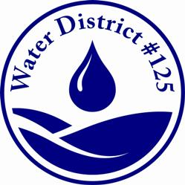 **Water District No.125**

3460 S 148th St, TUkwila, Wa. 98168

PO BOX 68147, SEATTLE, WA. 98168-0147

P: (206)242-9547 F: (206)248-1744

Small Works roster application

# BUSINESS CONTACT INFORMATION

|  |  |  |  |
| --- | --- | --- | --- |
| Company Name: |  | Email: |  |
| Contact Person: |  | Website: |  |
| Registered company addressCity, State ZIP Code |  |  |  |
| Office No: |  | Cell No: |  |
| Fax No: |  |  |  |

|  |  |  |  |
| --- | --- | --- | --- |
| WA State UBI NO: |  | Federal EIN: |  |
| WA Contractor’s License No: |  | Expiration Date: |  |

# City Contractor’s LIcense No: (as applicable)

|  |  |
| --- | --- |
| SeaTac: |  |
| Tukwila: |  |
| Burien: |  |

# indicate the services you wish to provide

|  |  |
| --- | --- |
| Mainline Repair or Replacement Y/ N | Water Service Repair or Replacement Y/ N |
| Leak Detection y/ N | PRV Repair and Maintenance Y/ N |
| Waterline Locating Y/ N | Plumbing Repairs Y/ N |

# References

|  |  |
| --- | --- |
| 1.) | Phone No: |
| 2.) | Phone No: |
| 3.) | Phone No: |

|  |
| --- |
| Please include a Certificate of Liability Insurance naming King County Water District # 125 as additional insured with the following;  General Liability $1,000,000 Each Occurrence  $2,000,000 Aggregate |
| Vehicle Liability $1,000,000 Combined Single Limit |