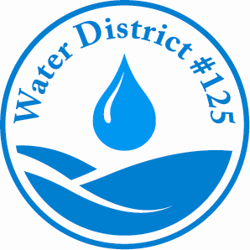
Water District #125
PO Box 68147
Seattle, WA 98168
(206) 242-9547 Fax (206) 248-1744
office@waterdistrict125.com

Payment Plan Agreement
Due to COVID-19 Pandemic

Effective Date: ___________________

Account Number: _______________________________

Property Owner: _______________________________

Tenant Name: _______________________________

Service Address: _______________________________

Phone Number: _______________________________

Option No. 1 – Three Month Plan 0% down payment
Zero percent (0%) down payment with the entire balance to be paid in three (3) equal monthly installments.

PAST DUE BALANCE ON ACCOUNT: $__________________

MONTHLY PAYMENT AMOUNT: $__________________

Option No. 2 – Six Month Plan 25% down payment
Twenty Five percent (25%) down payment with the remaining balance to be paid in six (6) equal monthly installments.

PAST DUE BALANCE ON ACCOUNT: $______________

25% DOWN $_____________

MONTHLY PAYMENT AMOUNT: $___________________

I hereby certify that I have been financially affected by the COVID-19 Pandemic which has affected my ability to make payments and agree to this payment plan. I understand that I must keep all installment payments current, PLUS pay each new water bill received within 30 days.

Owner Signature: _________________________________

District Representative Approval: _______________________ Date: _________

